ST 2 Assignment 1 Lab W4 Work
Task 1:
Draw
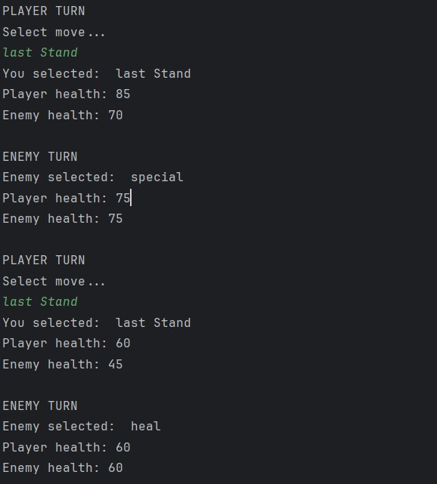
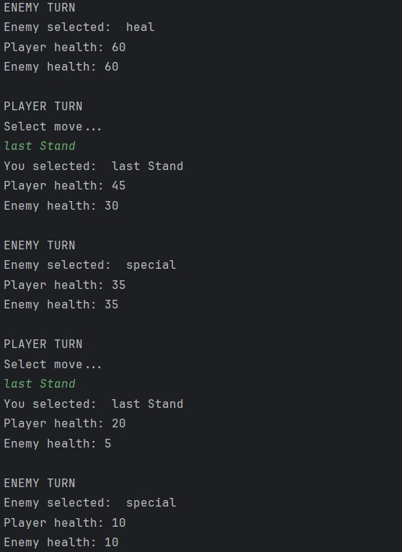
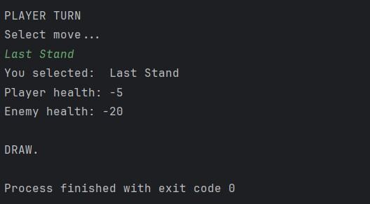
Win
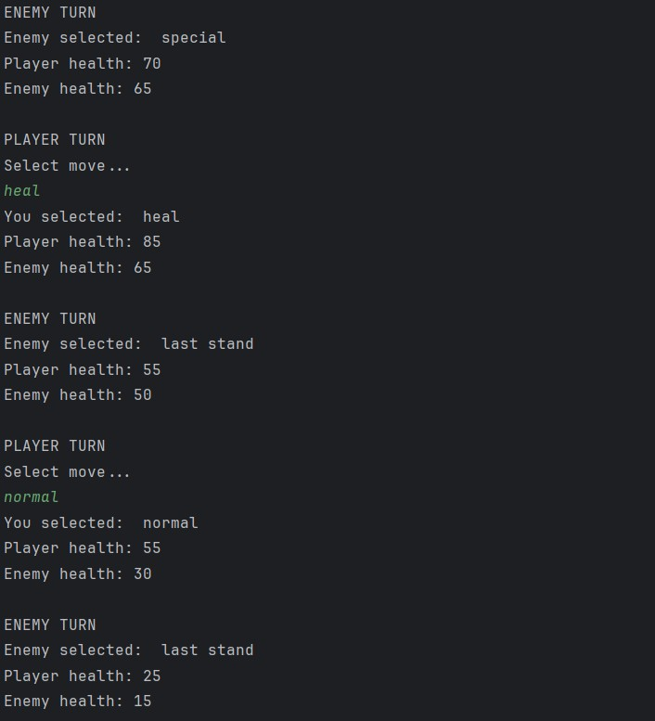
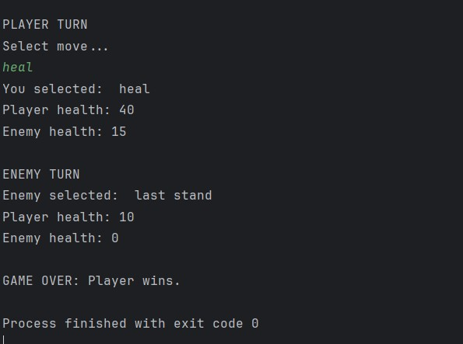

Loss
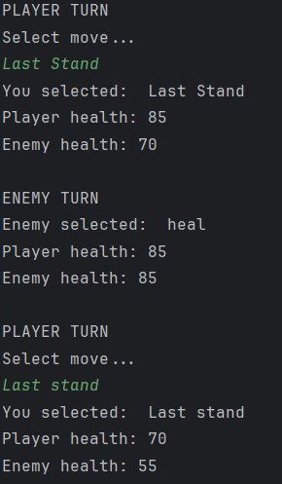
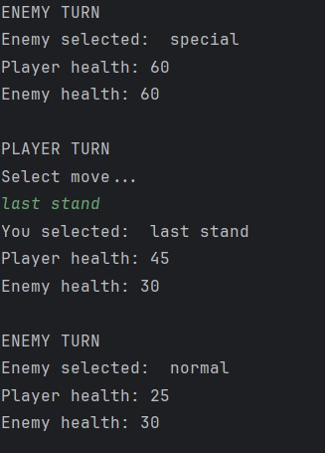
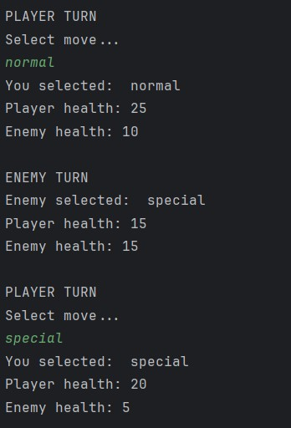
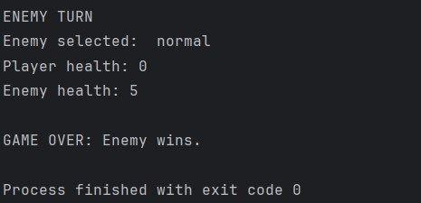

Task 2:
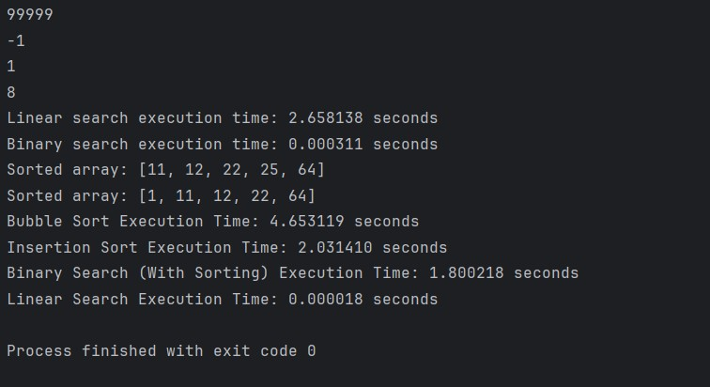
The Linear Search Algorithm is more efficient when the list being searched through is small, however if the list is large then the Binary Search Algorithm is faster as it halves the list every time unlike the linear algorithm that goes through them one by one.
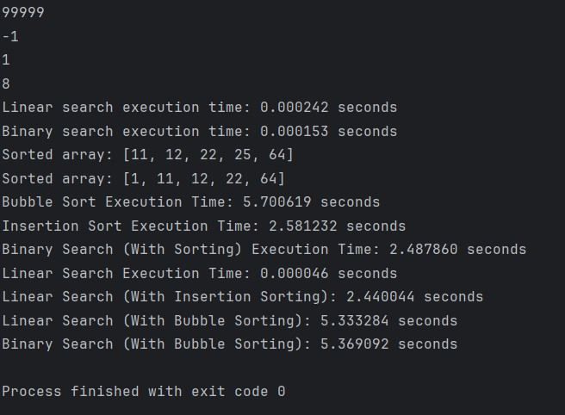
When the list is shrunk down to 500 and the target set to 70, the difference between the Linear and the Binary Algorithms is barely noticeable to anyone.

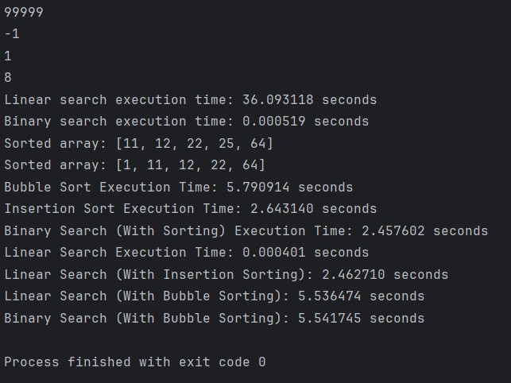
When the sorted list is increased to 9.9 million values, the difference becomes much more noticeable between the Linear algorithm and the Binary algorithm. The Linear process is much slower than the Binary one due to its method of going one at a time, unlike Binary which halves the list for each step.

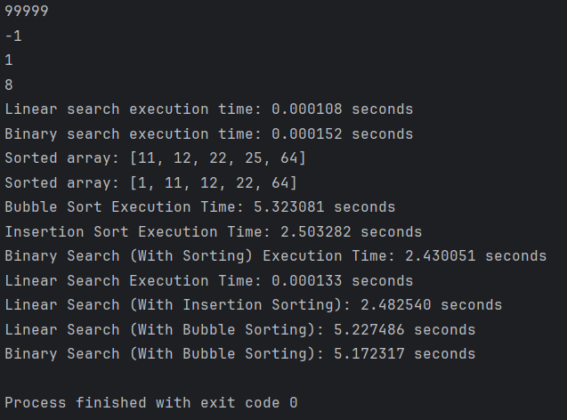
It is worth noting that regardless of the size of the sorted list, if the target value is low enough then it will always complete faster than the Binary algorithm as it cannot narrow down the value fast enough before the Linear Algorithm reaches the target. E.g. when the list size is 500 and the target is 22, the Binary list is just a bit slower than Linear, but if the sorted list is 1 million values long then the Binary Algorithms effectiveness slows down

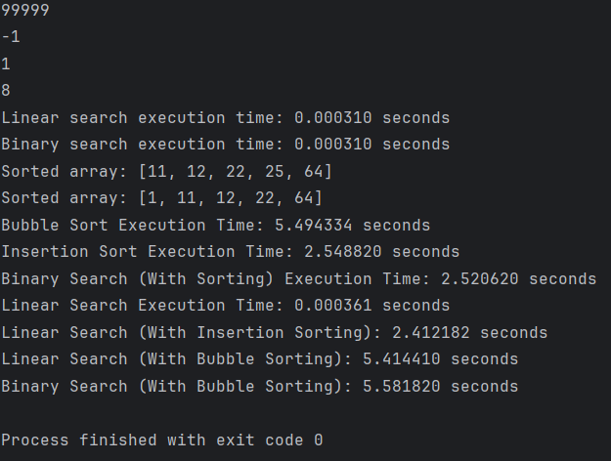
There are a few cases where if the sorted list is just the right size (in this case 100,000) and the target is low enough (99) then both the Linear and Binary Algorithms will find the target simultaneously, but generally using just Binary or both Binary and Linear Algorithms is the better choice as not all lists are sorted and the target is random, so for best coverage and to make sure the target isn’t located very early on in the unsorted list.

Task 3:

The Insertion Sort Algorithm is faster than the Bubble Sort Algorithm as Insertion Sort when the list is smaller, Bubble Sort gets worse the larger the list as it performs a lot more unnecessary swaps than the Insertion Sort does.

Task 4:
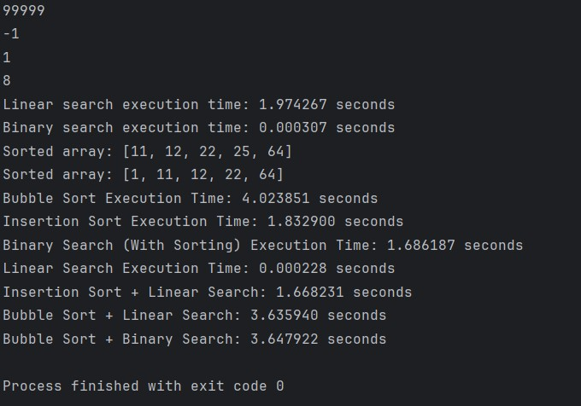
Out of all of the combinations, the most efficient Algorithm was the Binary Search with Insertion sorting, followed by Binary Search with Bubble sorting, then Linear Sorting with Insertion Sorting, and finally the slowest algorithm is Linear Searching with Bubble Sorting.

